Homework

Ana Katrina De Leon

Answer the questions by SQL.

1. List all the employees whose salaries are more than 3000.

**SELECT * FROM emp WHERE sal >= 3000;**

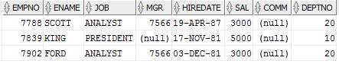

1. List all the employees whose names begin with “S”.

**SELECT * FROM emp WHERE ename LIKE 'S%';**

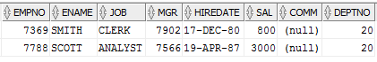

1. List the employees whose name is “SMITH”, “ALLEN” or “FORD”.

**SELECT * FROM emp WHERE ename IN ('SMITH', 'ALLEN', 'FORD');**

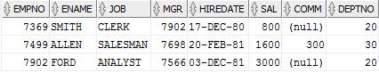

1. List all the employees whose department is “SALES”.

**SELECT * FROM emp**

**INNER JOIN dept**

**ON emp.deptno = dept.deptno**

**WHERE dept.dname = 'SALES';**

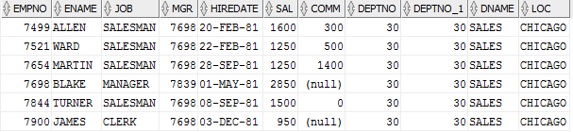

1. To get the value of average, biggest, smallest and total of each department, and order by department number.

**SELECT dept.deptno, AVG(sal), MAX(sal), MIN(sal), SUM(sal) FROM emp, dept WHERE emp.deptno = dept.deptno GROUP BY(dept.deptno) ORDER BY dept.deptno asc;**

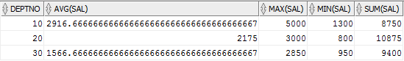

1. To get the total number of employees, whose salary is more than 3000 for each department.

**SELECT COUNT(ename) AS "NUMBER OF EMPLOYEES", sal, deptno FROM emp WHERE sal >= 3000 GROUP BY deptno, sal;**



1. To get the number of the average salary for each department, according to the department name in ascending order

**SELECT dept.dname, AVG(sal) as "AVERAGE_SALARY"**

**FROM emp**

**INNER JOIN dept**

**ON emp.deptno = dept.deptno**

**GROUP BY dept.dname**

**ORDER BY dept.dname ASC;**

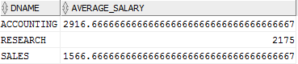

1. List the statistics of employees who have the same salary in each department, list their department number, salary, and number of employees.

**SELECT d1.dname, e1.sal, COUNT(e1.ename) FROM emp e1, dept d1, emp e2 WHERE e1.deptno = d1.deptno AND e1.sal = e2.sal AND e1.ename != e2.ename GROUP BY(d1.dname, e1.sal);**



1. List the number of department with more than 2 employees in the same department, showing the name of the Department, the name of the area, and the number of the employees in the same department

**SELECT d1.deptno, d1.dname, d1.loc, COUNT(e1.ename) FROM emp e1, dept d1 WHERE e1.deptno = d1.deptno HAVING COUNT(e1.ename) > 2 GROUP BY(d1.deptno, d1.dname, d1.loc);**

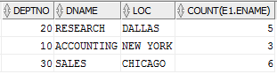

1. List the name and salary of employees whose salaries is higher than the average salary of the entire firm

**SELECT ename, sal FROM emp WHERE sal > (SELECT AVG(sal) FROM emp);**

